EXECUTIVE SUMMARY: 2020 Electoral Prioritization Strategy
To: Strategy / Operations Leadership
From: Strategic Data Analysis Team
Subject: Identification of Critical Decision Nodes (156 Swing Counties)

1. Strategic Recommendation (The Bottom Line)
It is recommended to immediately focus resources on 156 identified "Swing" counties (Battleground areas). These represent only 4.8% of the national territory but are the only regions where the margin of victory is less than 5%, making them the true deciders of the final outcome. Any shift in voter turnout within these specific nodes has a disproportionate impact on the national balance.

2. Business Case / Arguments
- Investment Efficiency: By deprioritizing the 84% of "Safe" counties, we can optimize budget allocation toward areas with high voter volatility.
- Demographic Breaking Points: Our analysis has detected that maximum competitiveness occurs within specific ethnic balance thresholds, allowing us to predict where margins will close before the final count.
- Risk of Inaction: Within the Top 10 priority counties, the margin is less than 0.3%. Even a minor sampling error or lack of presence in these zones guarantees the loss of competitive advantage.

3. Data Evidence & Visualization

A. The Electoral Balance (Margin vs. Population)
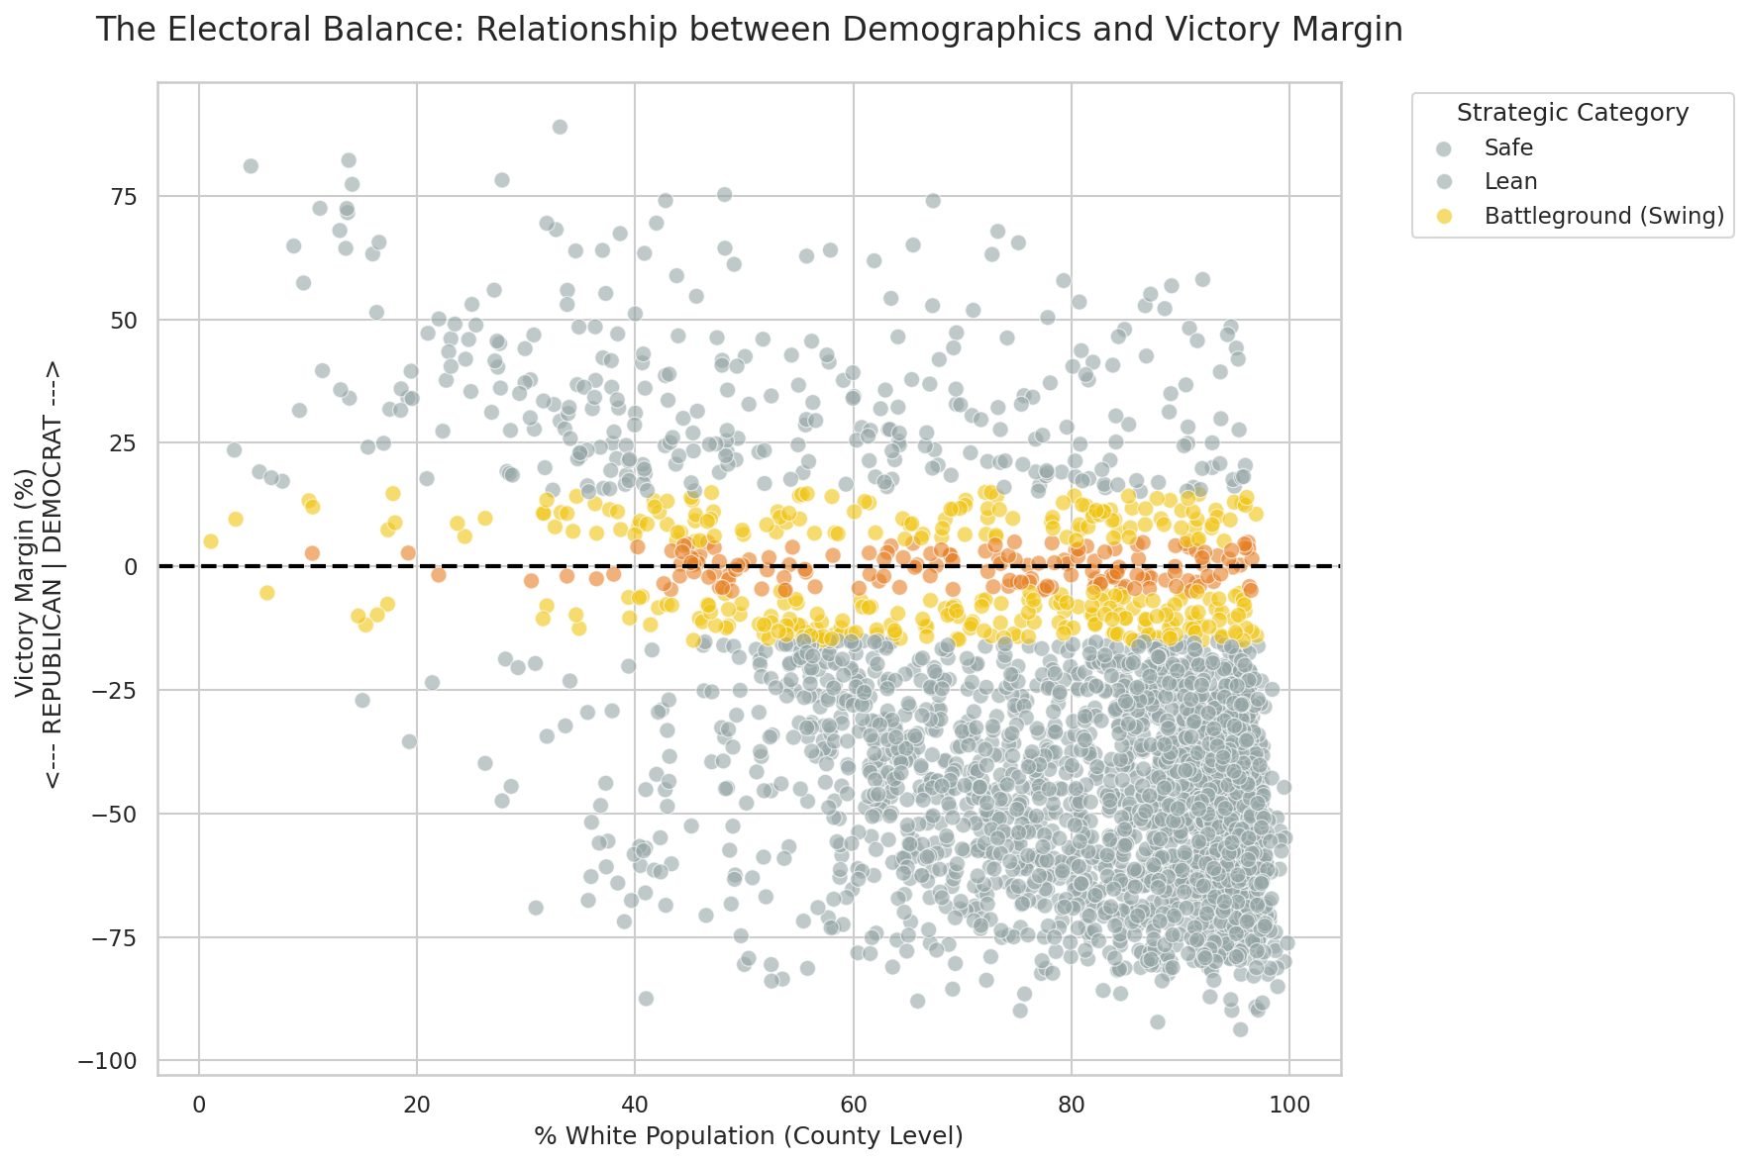

B. Multivariate Demographic Correlation
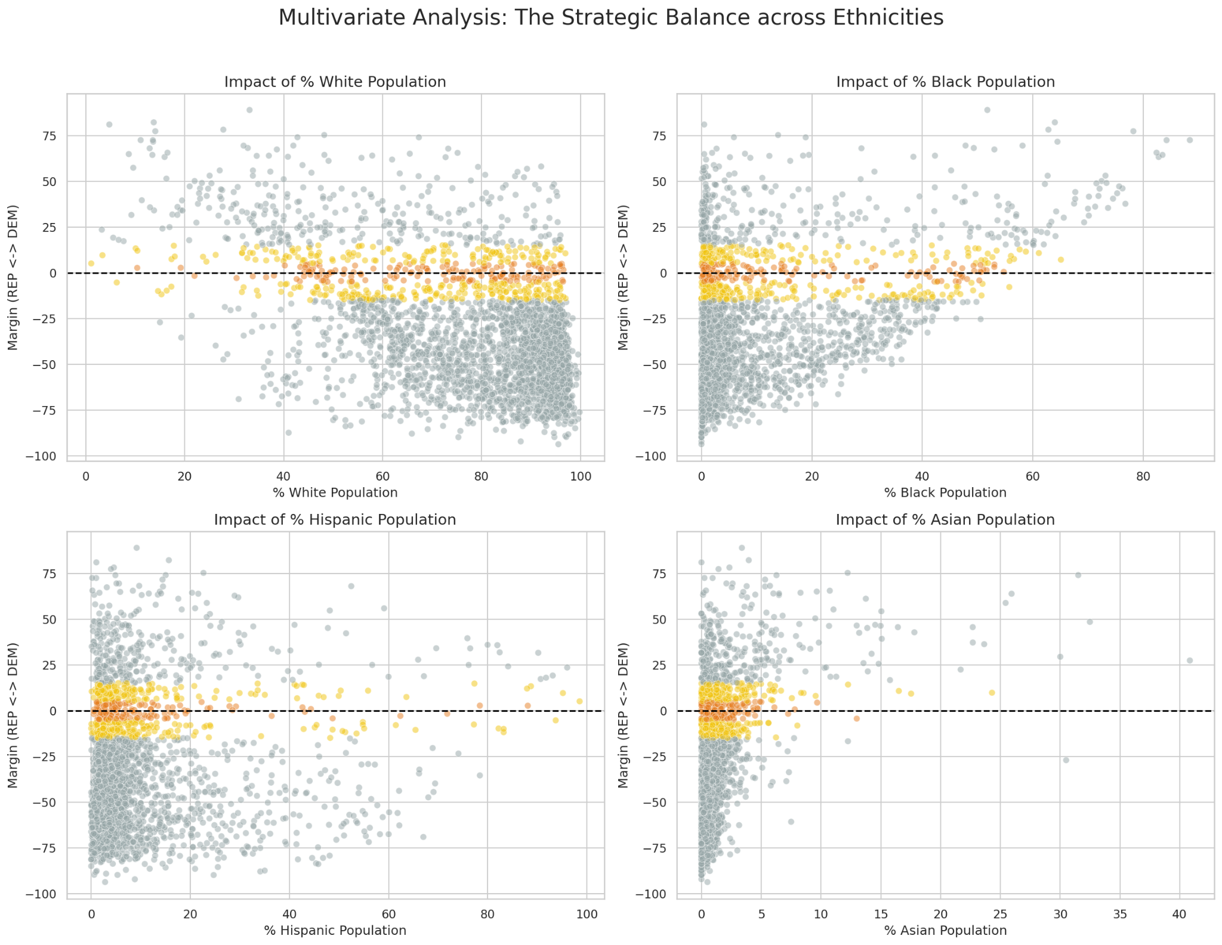

4. Action Plan (Next Steps)
Phase | Action | Deliverable
Phase 1 (Current) | Segmentation & Filtering | 156 Key Swing Counties CSV
Phase 2 (Day 3) | Geospatial Mapping | State-level Heatmaps

5. Appendix: High-Priority Identification (Top 10)
The following counties present the narrowest margins in the country and require immediate attention:

Rank | FIPS Code | Total Population | Victory Margin (%) | Strategic Status
1 | 36069 | 109,192 | -0.02% | High Priority (Battleground)
2 | 06027 | 18,373 | +0.15% | High Priority (Battleground)
3 | 36113 | 65,180 | -0.16% | High Priority (Battleground)
4 | 27131 | 64,886 | -0.17% | High Priority (Battleground)
5 | 36071 | 375,384 | -0.18% | High Priority (Battleground)
6 | 48439 | 1,914,526 | +0.22% | High Priority (Battleground)
7 | 12103 | 931,477 | +0.22% | High Priority (Battleground)
8 | 37127 | 94,722 | +0.23% | High Priority (Battleground)
9 | 23011 | 121,112 | +0.26% | High Priority (Battleground)
10 | 26145 | 196,479 | +0.30% | High Priority (Battleground)

Generated Document | Strategic Data Partner Methodology | v2.0

